### CHAPTER 1

**PREDICTIVE MANAGEMENT OF PV AND DOMESTIC DC LOAD**

## 1.1 Introduction

Solar power is a clean and inexpensive energy source which can be harnessed easily from anywhere in the world due to its abundance. Over the past few years solar systems are being extensively used to power small loads typically installed on roof tops of buildings. On site solar power for businesses and non-profits with small scale utilities have a large number of customers in the power market. Residential owners can install solar systems and design their premises to take full advantage of solar technology. Subsidies provided by the government for the installation of solar panels also add to their favour. Several factors have to be considered before employing a PV system like location, weather conditions, capital cost and maintenance. However these measures do not always yield state of the art performance in recent times.

In the present scenario solar energy is directly fed to the grid without checking the status of the grid. Power generated from the distributed solar panels doesn’t exceed the limit of penetration of the grid. However, in the future almost every house will be using DC loads. But the grid is not designed such as to integrate large amounts of varying solar power into it. So in order to face this issue and to control the excess power, utilities should have an estimate of how much amount of solar power will be added to the grid after domestic usage. This will assist the utility to make use of these resources to its maximum and maintain the stability of the grid. Predicting the power output of a solar panel also helps in optimal load scheduling by individuals, bidding in electricity markets etc. But the power output from a solar panel can change rapidly due to unexpected weather conditions. This makes forecasting the power output of a solar panel even more challenging.

Many maximum power point tracking (MPPT) algorithms have been introduced in recent years to maximize the generated PV power. These algorithms are not sufficiently robust because of fast-changing environmental conditions. In the soft computing-based MPPT category, the most popular techniques are Fuzzy Logic Control (FLC) [1], artificial neural network (ANN) [2], and other Computational Intelligence (CI) [3] methods.

The prediction of PV power includes certain modelling methods based on historical data [4]. In recent years. The prediction of PV power is similar to the load forecasting, and the research on the evaluation was put forward based on statistical analysis. The necessity of the evaluation of the load regularity has been expounded in [5].

PV power has randomness and volatility due to the light intensity, humidity, temperature, and so on. This uncertainty of PV output causes some adverse effects on the grid when it is connected on a large scale. Therefore, accurate PV power prediction is of great significance to the safe and economical operation of power systems. The PV output forecasting can be of different forecast horizons such as very short term, short term, medium term and long term PV output forecast.

Long term forecast (1 yr. to 10 yrs. ahead).

Medium term forecast (1 month to 1 yr. ahead).

Short term forecast (1 hr or several hrs ahead to 1 day or 1 week ahead).

Very short term forecast (1 min. to several min. ahead)

Short term PV output forecast can be utilized for automatic generation control (AGC), better unit dispatching, load scheduling and power plant operational management. It helps the grid to reduce the ancillary costs associated with weather dependency and ensure quality of energy. Reduction of the power system operational costs is a main factor to develop PV forecast models. PV output power forecast may also be part of smart grid (future generation power grids) energy management system along with load forecast.

Forecast model inputs also play a vital role in improving the prediction accuracy and model performance in terms of computational complexity and cost. Prediction error of forecast model is increased due to improper selection of forecast model inputs. Therefore, PV output forecast models are unable to correctly map all input variables as a forecast output due to poor selection of essential influential variables.

Many PV output forecast models used the historical PV output data as forecast model input. The historical PV output data may contain various spikes and non-stationary components due to uncertain meteorological conditions. As a result, these glitches in data will lead to higher forecast error due to improper training. The historical PV output data can be screened for smoothing. In addition, missing input data points in historical data will also play a role to increase the forecast error. Therefore, the forecast accuracy of the model can be considerably improved by input pre-processing.

## 1.2 Classification of forecast techniques

The figure 1, shows a broad way of classifying forecasting techniques used widely.

FORECASTING TECHNIQUES

PHYSICAL

STATISTICAL

MODERN

HYBRID

NWP

Time Series

Artificial Intelligence

Machine Learning

NWP+AI

Time Series+ML

Fig 1: Forecasting Techniques

# 1.2.1 Physical models

A well-known physical model is numeric weather predictor (NWP). This predictor is based on a set of mathematical equations, which governs the physical state and dynamic motion of the atmosphere. These models are based on the PV plant characteristic such as location, orientation historical data and meteorological variables. It also depends on global horizontal irradiance (GHI), relative humidity, wind speed and direction along with PV models [6]. The forecast performance of a physical model is higher, when the weather conditions are stable [7]. However, the forecast accuracy is largely affected due to huge changes in meteorological variables.

# 1.2.2 Statistical techniques

Statistical techniques are dependent on the learning process of the forecast model with historical influential variables. The forecast model tries to minimize the network learning error by using the difference between network predicted PV output power and actual measured values. Forecast accuracy of statistical models relies on the length and quality of historical input data. Statistical techniques have two sub groups named as time series and artificial intelligence (AI) based forecast models.

# 1.2.2.1 Time series models

In practice a suitable amount of data is fitted to a given time series and the corresponding parameters are predicted using the known data values. It comprises methods that attempt to study the nature of the series. In the time series forecasting method a suitable mathematical model is developed using past data, which holds the underlying data generating process for the series. This approach is particularly useful when there is no previous knowledge about the statistical pattern followed by the successive observations.

# 1.2.2.2 Artificial intelligence (AI)

Among the AI techniques, neural network (NN) is more popular and used as a power computational tool with higher degree of success since 1980. Generally, NN models produce higher forecast accuracy. It has the ability to capture sharp changes in the output with help of the intelligent training process of neural networks. An adaptive and robust NN training method can further improve the capability of the network to learn the complex relationship between input and output variables. Artificial neural network(ANN) based models map the input to model output without formulating the complex relationship between them. They attempt to model the simplest form of nonlinear behaviour of neurons. ANN model can map the input output relationship by using a feedback error system.

# 1.3 Machine Learning : A Closer Look

Machine Learning (ML) methods are being currently used as alternatives to statistical ones for time series forecasting. The objective of ML methods and statistical ones are the same. They both aim at increasing forecasting accuracy by minimizing some loss function, usually the sum of squared errors. Their difference lies in how such a minimization is done with ML methods utilizing nonlinear algorithms to do so while statistical ones use linear processes. ML methods are computationally more demanding than statistical ones, requiring greater dependence on computer science to be implemented, placing them at the intersection of statistics and computer science.

### CHAPTER 2

LITERATURE SURVEY

In literature, different techniques have been used to predict photovoltaic (PV) power output. These approaches can be classified as direct and indirect techniques. Direct methods are based on the historical PV outputs and weather data as inputs . In indirect methods, solar radiation is predicted and these values are used to predict PV power output. Hiyama and Kitabayashi [8] developed an artificial neural network to predict maximum power generation from a PV system. They used solar irradiation, air temperature and wind velocity as input parameters. From the results, it was proved that the proposed method was able to provide better prediction than direct methods.

Yang et al. [9] proposed a weather-based hybrid model for a day-ahead hourly prediction of PV power. The authors used self-organising map (SOM) and learning vector quantization (LVQ) networks for arranging the historical PV power output data. Support vector regressions (SVR) was then employed to train the given dataset, and a fuzzy inference method was used to select an appropriate training model. It was found that the proposed method had better performance than the simple SVR and ANN.

It is evident from the literature that out of different methodologies applied to predict photovoltaic power output, the Artificial neural network is one of the most widely used methods. However, ANN requires the user to specify exact parameters of the model (e.g. no. of hidden layers, neurons, number of neurons in hidden layers, no. of training cells, etc). Also, ANN has some drawbacks while dealing with unexpected data. On the other hand, fuzzy logic cannot learn directly from historical data and may not be accurate as it is based on human knowledge [10]. Generating high end rules for fuzzy logic systems is a challenging task, and therefore best practices or human knowledge is often used to develop initial rules. A study on probabilistic forecasting techniques for PV power generation can be found in van der Meer et al. [11].

Successful implementation of regression analysis to generate probabilistic forecasts of solar energy has recently drawn a lot of attention. The same has been demonstrated by many authors in their work. Also load forecasting problems are dealt in similar ways as power forecasting.

## Short Term Load Forecasting Methods

The system load to be forecasted is a random nonstationary process consisting of

several of individual components. Therefore, the list of possible approaches to the load forecasting is wide. Some common methods are discussed below.

1. Time-of-day method: In the simplest form, a time-of day method takes the previous week’s actual load pattern as a model to predict the load of the present week. Alternatively, a set of load patterns is stored for typical weeks with different weather conditions. These are then heuristically combined to create the forecast.
2. Stochastic time-series method: This method has many attractive features. First, the theory of the models is well known hence it is easy to understand how the forecast is composed. The parameters of the model are easy to calculate; the estimate for the variance of the white noise component allows the confidence intervals for the forecasts to be created. The model identification is also relatively easy. Established methods for diagnostic checks are available. Moreover, the implementation of the model is not difficult. The weakness in the stochastic models is in their adaptability. In reality, load behaviour can change quite quickly in certain parts of the year. Another problem is the handling of the anomalous load conditions. If the load behaviours is abnormal on a certain day, this deviation from the normal conditions will be reflected in forecasts into the future.
3. State-Space method: There exist a number of variations of the state-space model. Some examples can be found in Camp and Ruiz[12]. According to Gross and Galiana, a potential advantage over Integrated Autoregressive Moving Average(ARIMA) models is the possibility to use prior information in parameter estimation via Bayesian techniques[13]. It is also pointed out that the advantages are not very clear and more experimental comparisons are needed.
4. Expert systems: Expert systems are heuristic models, which are usually able to take both quantitative and qualitative factors into account. A typical approach is to try to imitate the reasoning of a human operator. The method for a human expert to create the forecast is to search in the history database for a day that corresponds to the target day with regard to the day type, social factors, and weather factors. Then the load values of this similar day are taken as the basis for the forecast. An expert system can thereby be an automated version of this kind of a search process[14]
5. Regression: Regression models, normally, assume that the load can be divided into a standard load component and a component linearly dependent on some other variables. The most typical explanatory variables are weather factors. A typical regression model has been used by Ra¨sa¨nen and Ruusunen[15]. The load is divided into a repeated component and a temperature dependent component. The repeated component corresponds to the load of a certain hour in the average temperature of the modelling period. More complicated model variations have also been proposed. Some models use earlier load values as explanatory variables in addition to external variables. Regression methods are among the oldest methods suggested for load forecasting. They are quite immune to occasional disturbances in the measurements. The easy implementation is the strength of this method.

### Chapter 3

COMPONENTS

## 3.1 ACS712 Current Sensor

Various devices need a different amount of current based on their functionality.

Every device has its own maximum peak current and voltage values. If the current of more than maximum peak value is provided, devices may burn and get damaged. Hence to avoid such conditions and to monitor the amount of current required current sensors are used. It is also used to measure the amount of current drawn by equipment connected to it.

There are two ways of sensing current :

# Direct sensing:

In this type of sensing, Ohm’s law is used to measure the voltage on the conductor whenever there is a flow of current. Some of the other examples are thermometers and barometers.

# Indirect sensing:

When current flows through the conductor, a magnetic field is produced. The current is measured by calculating this magnetic field. Hall effect sensors, fiber optic current sensors are used to sense the magnetic field. ACS712 Current Sensor uses the Indirect Sensing method to calculate the current.

# Working Principle:

ACS712 current sensor works on the principle of Hall effect which was discovered by Dr. Edwin Hall. According to this principle, when a current-carrying conductor is placed in the magnetic field, a voltage is generated perpendicular to the directions of both the current and the magnetic field.

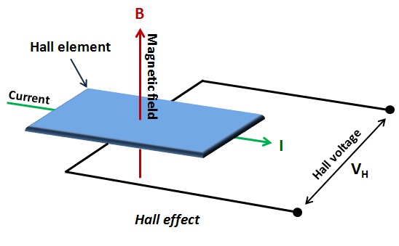

Fig 3.1Working of hall effect Sensor

The conductor is carrying a current (I) and is placed into a magnetic field (B) which is perpendicular to the direction of flow of current, due to the presence of Lorentz force the path of current flow has deviated and it is no more uniform from its actual path due to which a potential difference is created. This voltage is known as Hall voltage and its value is in the order of microvolts. The Hall voltage is directly proportional to the magnitudes of I and B. Hence current can be calculated from the measured Hall voltage.

The accuracy of the device is decided by the proximity of the magnetic signal to the Hall sensor. This sensor can measure both AC and DC currents. It can measure current ranging from +5A to -5A, +20A to -20A, and +30A to -30A.

Interfacing this module with any Microcontrollers is easy since it outputs analog voltage ranging from 0V-5V.

In our project, we have used the ACS712 current sensor to measure the current drawn by the solar panel and the loads. It is connected in series with the panel and the output of this sensor is connected to Arduino UNO which is further used to calculate Power.

# Applications of ACS712 Current Sensor:

1. ACS712 Current Sensor is used in Peak detection circuits
2. Rectification circuits
3. Circuits to increase the gain
4. Overcurrent fault latch
5. Motor control circuits
6. Load detection and management

## 3.2 Relay

The relay is an electromechanical switch which is used to safeguard the devices and also used as a protecting and controlling device for various circuit and electrical networks. It uses electrical contacts to either complete or interrupt a circuit. These relays can work with both AC and DC supply.

The two common types of relays are electromechanical relays and solid-state relays. In electromechanical relays, the magnetic force is used to either open or close the contacts. But in solid-state relays, there are no contacts and switching operation is totally electronic. Heavy-duty equipment requires the switching abilities of electromechanical relays. Solid State Relays uses electronic devices such as silicon controlled rectifiers.

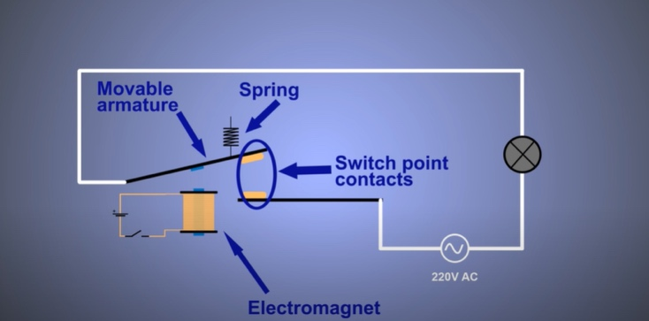

Fig. 3.2 Working of Electro-Mechanical Relay

An electromechanical relay consists of three terminals

* Common (COM)
* Normally closed (NC) contacts
* Normally opened (NO) contacts.

There are two circuits the control circuit and load circuit.

# Normally opened (NO) contacts:

The current starts flowing when the control switch is ON, it generates a magnetic field that attracts the armature and the load circuit is closed.

Normally opened contacts are generally used when a device must function in response to a specific signal.

# Normally closed (NC) contacts:

It operates when the relay is not energized. When there is no voltage, it cannot attract the armature, thus the initial position is the armature connected in a normally closed position.

Normally closed contacts are generally used when a device must stop functioning in response to a specific signal.

# Parts of the relay:

1. **Contacts:** These are the conducting parts that help the flow of current. They either open or close the circuit.
2. **Armature:** The armature opens and closes the contacts.
3. **Coil:** coil is wound around the core. When current flows through the coil, an electromagnetic field is generated.
4. **Frame:** Frame contains and supports the parts of the relay.

# Applications of relays:

1. Control panels
2. Automation system
3. Commercial and Domestic buildings
4. Overcurrent detector
5. Overload detector

## 3.3 Voltage Divider

A voltage divider is a simple circuit that can produce a portion of its input voltage as an output. This circuit consists of a series of resistors or any passive elements and a voltage source, a voltage source is provided across these series resistors. This circuit is also called a potential divider. The source voltage gets divided at each resistor but the current value remains the same in series connection.

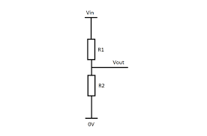

Fig.3.3 Voltage Divider

R1 is the resistance close to supply voltage, R2 is resistance near to the ground. VOUT is the voltage drop across the resistor, R2. It is the divider voltage which is the output.

## 3.4 Arduino Uno

The Arduino Uno is an open-source microcontroller board based on the Microchip ATmega328P microcontroller and developed by Arduino.cc.

It is the periphery of ATmega328P microcontroller equipped with sets of digital and analog input/output pins, serial communication pins, power pins, PWM pins which can be used to interface various sensors, drivers, actuators with the microcontroller. In our project, we have used an Arduino UNO to interface Current sensor to measure the input current from the solar panel and relay to protect and control the circuit.

# Pin description :

Pins have a standard rating ranging between 20mA to 40mA.

To limit the current within the safe limit internal pullup resistors are used but if a high amount of current flows to the Arduino then even these resistors cannot protect the board and it leads to damage of the board.

LED: Arduino has a built-in LED at pin 13.It Provides HIGH value to the pin will turn it ON and LOW will turn it OFF.

Vin: Vin is used to providing supply voltage. It provides an input voltage to the Arduino board

5V: 5V pin is used to provide an output voltage. Arduino can be powered up using either USB, Vin pin of the board or DC power jack. USB supports voltage of 5V, Vin and Power Jack supplies a voltage ranging between 7V to 20V.

GND: These are ground pins. There are 3 GND pins in Arduino UNO

Reset: This button is used to restart the program from the beginning. Arduino has the ability to reset using programming in IDE.

PWM: Pins 3,5,6,9,10, 11 are marked as PWM. These pins are configured to provide an 8-bit output PWM.

Serial Communication: Serial Communication is provided by 2 pins Rx and Tx ie Pin 0 and Pin1.

External Interrupts: Pin 2 and 3 are used for providing external interrupts.

# Features of Arduino UNO:

* Arduino Uno consists of USB interface i.e. USB port is added to the Arduino board to interface Arduino with a computer to set up the serial communication
* 14 digital I/O pins
* 6 analog pins marked as A0 to A5 has a resolution of 10bits
* Atmega328 microcontroller.
* It also facilitates serial communication using Tx and Rx pins
* The ATmega328P microcontroller has a number of features like timer, PWM modulation, counters, interrupts, and based on a 16MHz clock
* The Reset pin helps to clear the memory of the Arduino and it takes back the running program in the initial stage. This pin is useful when the board hangs up and by pressing this button it starts the program right from the beginning.
* 13KB of flash memory is used to store the code
* A voltage source of 5V is required to turn on the board which can be provided using a USB port or external adapter
* It also consists of a voltage regulator which regulates the incoming voltage and keeps the board within safe permissible limit when it is connected to external devices or circuits

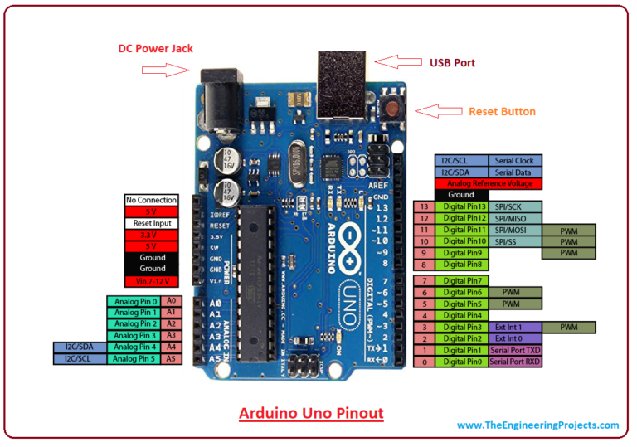

Fig. 3.4 Arduino Uno pin map

## 3.5 Raspberry Pi

The Raspberry Pi is a series of small single-board computers developed in the United Kingdom by the Raspberry Pi Foundation. The Raspberry Pi is a computer that runs Linux, it provides a set of GPIO (general purpose input/output) pins that allow various devices like sensors, electronic components and allows to explore the Internet of Things (IoT).

There are three generations of Raspberry Pi: Pi 1, Pi 2, and Pi 3, and there are a Model A and a Model B for these generations.

The SD card inserted in the slot on the Raspberry Pi is used as the hard drive or external storage. The monitor can be interfaced using HDMI port.

* It consists of ARM CPU/GPU it is a Broadcom BCM2835 System on a Chip (SoC) that's made up of an ARM central processing unit (CPU) and a Video core 4 graphics processing unit (GPU). GPU is used to handles graphics output and The CPU handles all the computations
* GPIO is the exposed general-purpose input/output pins which are used to interface external devices.
* An RCA jack is used to connect TV and other output devices.
* Audio out is a 3.55-millimeter jack used for connecting audio output devices like headphones or speakers etc.
* A USB port is the common port for  peripheral devices like a keyboard or mouse to connect with Pi
* HDMI cable is used to interface high-definition TV or any other devices which use an HDMI port
* Raspberry Pi can be powered through Micro USB port
* For wired network access, Ethernet connectors are used. This facility is available only with Model B
* The  Broadcom chip has 256 MB of RAM, which runs at 700 MHz and includes a 1080p-capable GPU.

## 3.6 Solar Panel

Solar panels are used to convert light energy into electricity that can be used to power electrical loads.

 Solar panels are composed of several solar cells which are again composed of layers of silicon.

 A Solar panel is an assembly of photovoltaic cells mounted in a frame. Photo-voltaic cells use sunlight as a source of energy and generate direct current electricity. The resulting energy generated from photons striking the surface of the solar panel allows electrons to knock out of their atomic orbits and they are released into the electric field generated by the solar cells. This process is known as the Photovoltaic Effect. Each panel produces a very small amount of energy but can be connected together with other panels to produce higher amounts of energy such a system is known as a solar array. The solar panel(or array) produces energy in DC. Most of the electronic devices use DC current but the electrical utility grid provides (and requires) alternating current. Hence an inverter is used to convert the DC to AC.

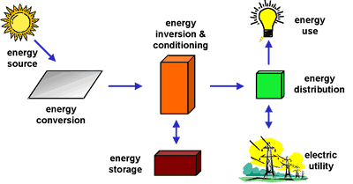

Fig. 3.5 Solar power Utilisation

A photovoltaic (PV) system is composed of one or more solar panels combined with an inverter and other electrical and mechanical hardware.

PV systems can vary in size from small portable systems to large utility-scale generation plants.

# Components of PV system:

1. Solar panel
2. Inverter
3. Battery or energy storage system
4. Converter
5. Load

PV array: PV array is the combinations of multiple solar panels which are used to convert solar energy to electrical energy

Battery: They are used to store the electrical energy produced by PV array during sunlight hours and supply it to electrical loads whenever needed( night or cloudy days). Batteries are used in a solar tracking system to track MPPT to operate the PV system at MPP in order to provide electrical loads with stable and maximum voltages. Most commonly used battery in PV systems are deep-cycle lead-acid batteries

Charge controller: batteries cause losses in the PV system due to insufficient battery maintenance and rapid recharging time. Hence a charge controller is used to prevent the battery from overcharging and over-discharging.

Inverter: PV array produces DC output. Most of the electronic devices operate with DC supply like Mobile, TV, etc but the electrical utility grid operates with AC. Hence an inverter is used to convert DC to AC.

# There are two types of PV system:

# Grid-connected photovoltaic systems :

Grid-connected photovoltaic systems consist of PV arrays that are connected to the grid through a power conditioning unit (PCU) and are designed to operate in parallel with the electric utility grid. PCU consists of the MPPT, the inverter, the grid interface, and BMS needed for efficient system performance.

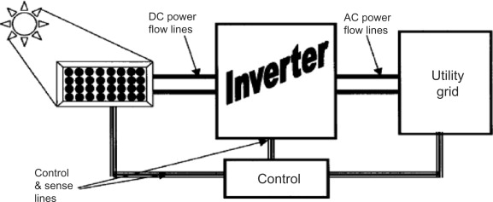

Fig. 3.6 Schematic of Grid-connected photovoltaic systems

# Standalone PV system:

Stand-alone photovoltaic systems are designed to operate independent of the electric utility grid and are available in different sizes to supply certain DC and/or AC electrical loads.

* Direct-coupled system: Standalone PV system designed without battery storage they are known as a direct-coupled system, and DC output of a photovoltaic module or array is directly connected to a DC load. There is no energy storage battery system in direct-coupled systems hence load operates only during sunlight hours. They are suitable in applications such as water pumps, circulation pumps, and ventilation fans



Fig. 3.7 Schematic of Direct-coupled system

* Standalone system with battery storage: In many stand-alone PV systems, batteries are used for energy storage. They can power both DC and AC loads. They generally include a charge controller, batteries, inverters, and PV arrays.

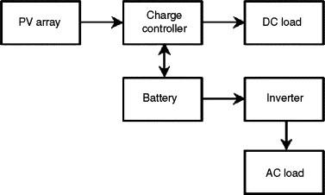

Fig. 3.8 Schematic Standalone system with battery storage

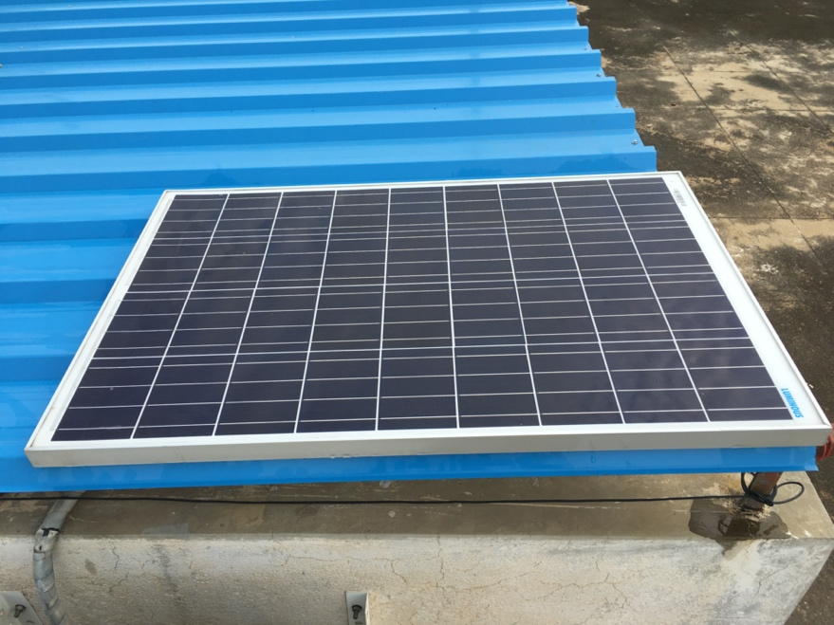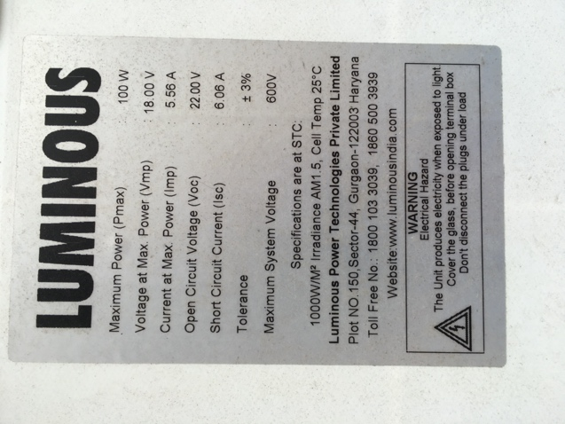

Fig. 3.9 Panel and Specifications of solar panel used

## 3.7 Buck Converter

A Buck converter is a DC to DC electronic converter. The output voltage is transformed to a voltage level less than the input voltage. It is also called a step-down converter. Since in step down transformer the output voltage is step down to voltage level than the input voltage, buck converter analogous to step down transformer hence it is called step down converter.

This converter is used to step down the voltage from the solar panel so that the devices like Arduino will be safeguarded.

According to the law of conservation of energy, the input power has to be equal to output power assuming no losses in the circuit.

Input Power (Pin) = Output Power (Pout)

In a buck converter Vin > Vout, hence the output current will be greater than the input current. Therefore in the buck converter Vin > Vout and Iin <Iout

# Working Principle of Buck converter:

The inductor in the input circuit resists change in input current. The inductor stores energy in the form of magnetic energy when the switch is ON and when the switch is closed it discharges. The value capacitor in the output circuit is very large such that the time constant of the RC circuit in the output stage is high. When the time constant is large compared to the switching period a constant output voltage Vo(t) = Vo(constant) is ensured.

# Modes of operation of Buck converter

There are two modes operation of Buck converter

1. **Continuous conduction mode**

In this mode, the current through induction never becomes zero. Before the start of the switching cycle, the inductor partially discharges.

1. **Discontinuous conduction mode**

In this mode, the current through induction becomes zero. At the end of the switching cycle, the inductor is completely discharged.

In our project, we have designed our own buck converter using Autodesk Eagle software, the schematic and board design of which are shown below.

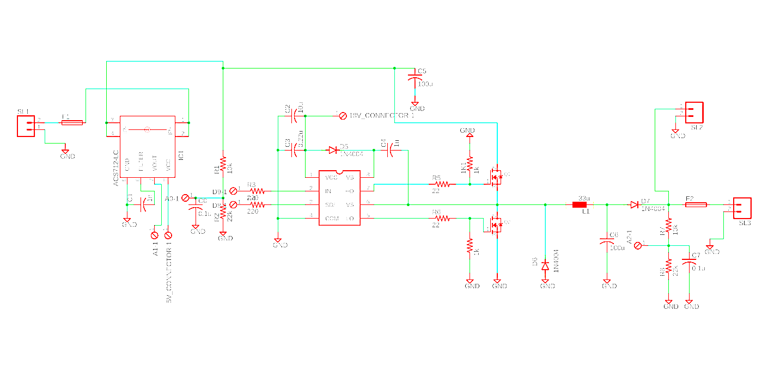

Fig. 3.10 Schematic of buck-converter designed in Eagle CAD

Before manufacturing the PCB, the schematics were tested on a breadboard and the output was observed on an oscilloscope.

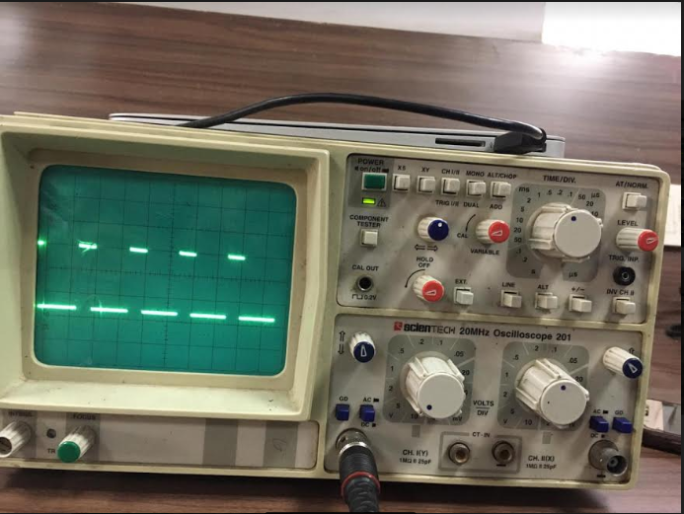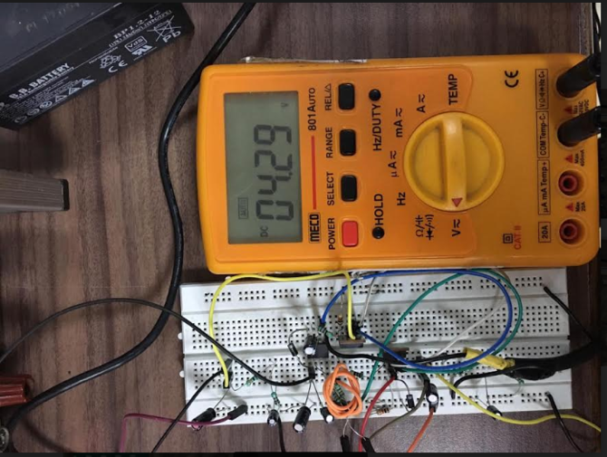

Fig. 3.11 Testing of buck converter before manufacturing

### Chapter 4

HARDWARE SETUP

We have two different hardware setups to collect the solar panel power generation data and the domestic load usage data.

## 4.1 Solar Panel Data Collector

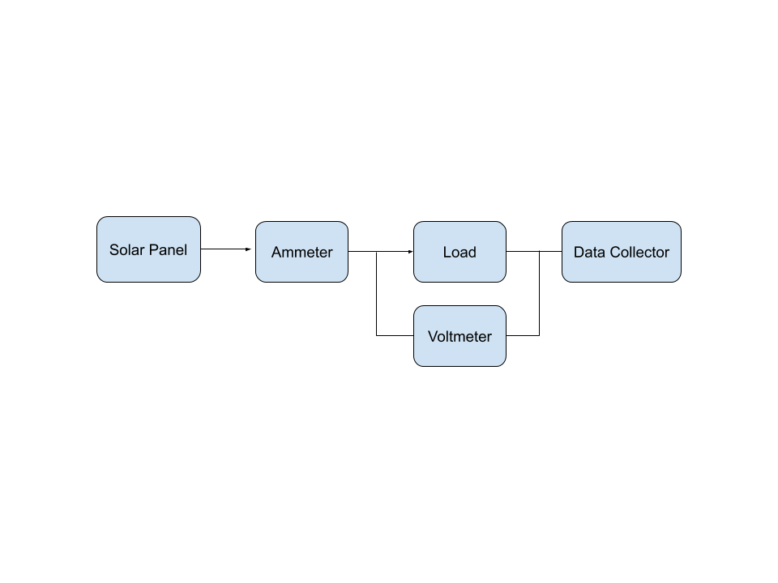

Fig. 4.1 Block diagram of Solar Panel Data Collector

To have a good accuracy while predicting future power generating capabilities, it is important to have good data over a prolonged time period. Collecting data manually over a course of 1 year tends to become tedious and cannot be done for fixed interval of time

Hence, we developed a circuit to help us collect data continuously over a period of 1 year with minimal errors and deviations.

A timer circuit (RTC) was initially used to collect data every 3 minutes and store in to an SD card in comma separated value (.csv) format. Due to an issue of redundancy errors, the RTC module was eliminated and a Raspberry Pi 3 B+ was introduced into the circuit to monitor and collect the data.

The solar panel was connected to a load through a relay circuit. A digital ammeter (ACS712) was connected in series and a voltage divider circuit was connected in parallel to the load. The relay helped in toggling between open and closed circuits for voltage and current value collection respectively.

The Arduino was connected to the Raspberry Pi serially, and all the data collected by the Arduino was sent immediately to the Raspberry Pi.

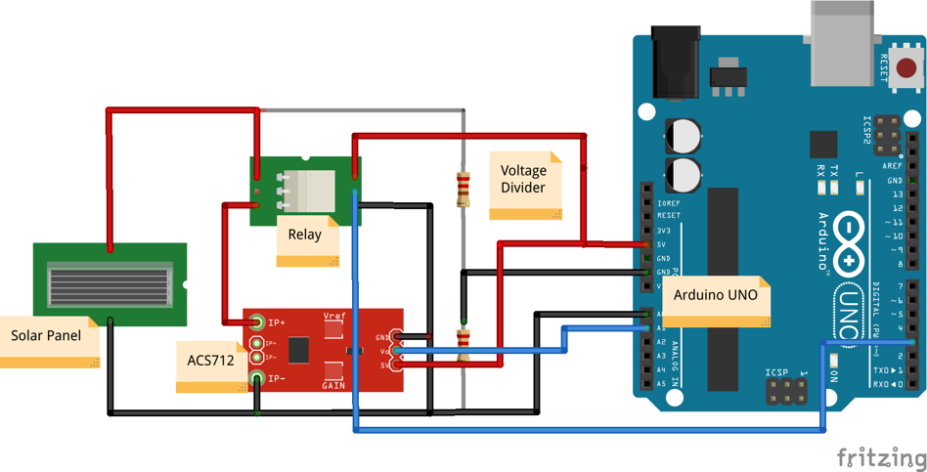

Fig. 4.2 Circuit Diagram of Solar Panel data Collector

A python script was run continuously on the Raspberry Pi to read, format and store the data in a comma Separated value (.csv) file format. The stored data then periodically got uploaded to a git server which allowed monitoring of the data remotely.

## 4.2 Domestic Load Usage Replicator

To be able to predict the domestic load usage, like the solar panel data, it is necessary collect the domestic load usage data as well. To collect the usage data from an actual house, it is quite tedious and gruesome to attach a power meter to each appliance drawing power.

To ease the process of collecting the data, a Load usage replicator was developed with the help of high wattage bulbs and regular lighting lamps. To dissipate the heat generated by the high wattage bulbs, a heat sink was placed in contact with the bulbs. A 12V SMPS was deployed to power the active loads.

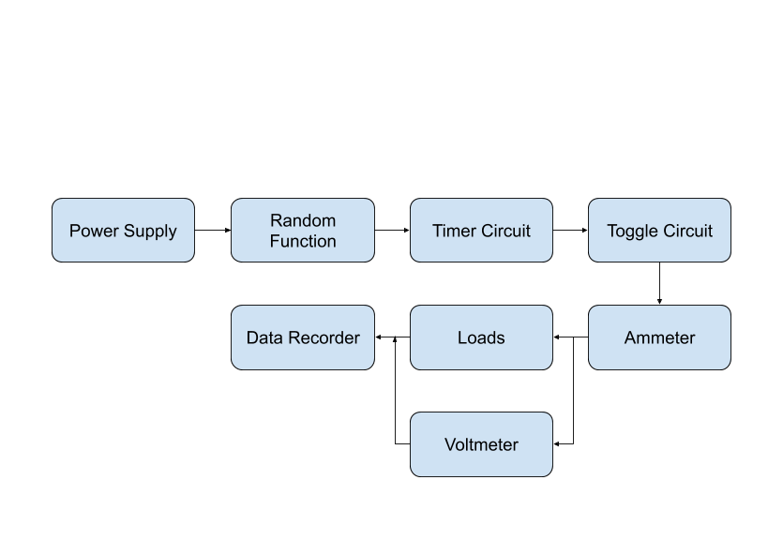

Fig. 4.3 Block diagram of Domestic Load usage replicator

A random function was created to replicate the load usage through the day. The function was given different parameters throughout the week to simulate the actual presence of people and their plausible power consumption.

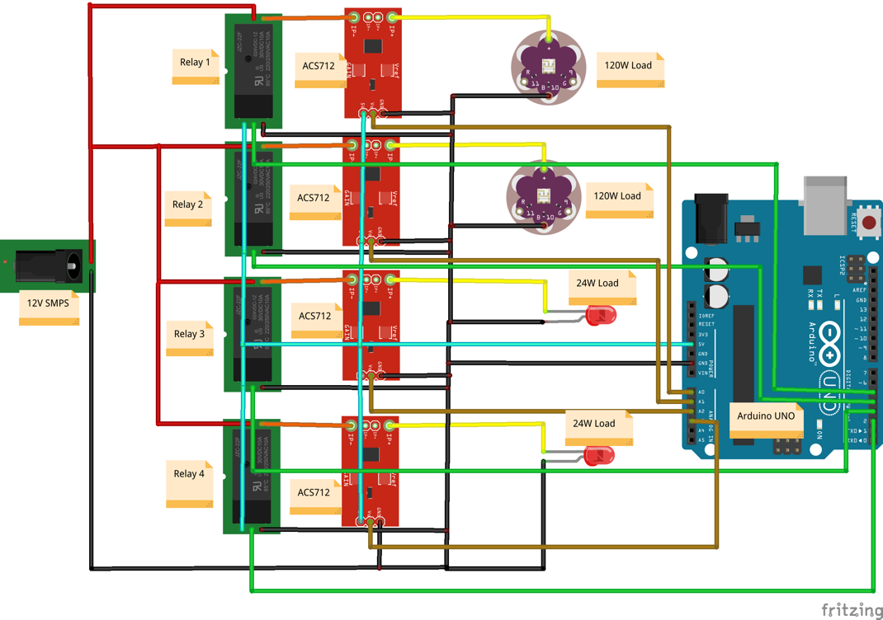

Fig. 4.4 Circuit diagram of Domestic Load usage replicator

The data was collected every minute, and was stored on an SD card in a comma separated value (.csv) file format. Periodically, the SD card was removed and the data stored in the same was uploaded to a git server to be access remotely.

### Chapter

CODE

## Solar Panel Data Collector : Arduino

#include <Wire.h>

#include <TimeLib.h>

//**********************VALUES FOR millis**********************//

unsigned long previousMillis1 = 0;

unsigned long previousMillis2 = 0;

const long interval1 = 180000;

const long interval2 = 1000;

//**********************INITIALLZING PINS**********************//

int relay_Out = 2;

int SC_Current = A0 ;

//int load_Current = A2 ;

int OC_Voltage = A1 ;

//**********************VALUES FOR ACS712**********************//

int sensitivity = 100; //100 for 20A Module and 66 for 30A Module

int volt_read= 0;

int ACSoffset = 2500;

double Voltage = 0;

double Amps = 0;

//**********************VALUES FOR VOLTMETER**********************//

float vout = 0.0;

float vin = 0.0;

float R1 = 100000;

float R2 = 22000;

int value = 0;

//*****************FUNCTION FOR READING CURRENT*****************//

float readCurrent(float raw_Current)

{

float AcsValue=0.0,Samples=0.0,AvgAcs=0.0,AcsValueF=0.0;

for (int x = 0; x < 150; x++){ //Get 150 samples

AcsValue = analogRead(raw_Current); //Read current sensor values

Samples = Samples + AcsValue; //Add samples together

delay (3); // let ADC settle before next sample 3ms

}

AvgAcs=Samples/150.0; //Taking Average of Samples

//((AvgAcs * (5.0 / 1024.0)) is converitng the read voltage in 0-5 volts

//2.5 is offset(I assumed that arduino is working on 5v so the viout at no current comes

//out to be 2.5 which is out offset. If your arduino is working on different voltage than

//you must change the offset according to the input voltage)

//0.100v(100mV) is rise in output voltage when 1A current flows at input

AcsValueF = (2.5 - (AvgAcs * (5.0 / 1024.0)) )/0.100;

return AcsValueF; //Print the read current on Serial monitor

}

//*****************FUNCTION FOR READING VOLTAGE*****************//

float readVoltage(float raw_Voltage)

{

double VolValue=0.0,Samples=0.0,AvgVol=0.0;

for (int x = 0; x < 500; x++)

{ //Get 150 samples

VolValue = analogRead(raw_Voltage); //Read current sensor values

Samples = Samples + VolValue; //Add samples together

delay (3); // let ADC settle before next sample 3ms

}

AvgVol = Samples/500.0;

AvgVol = ((AvgVol*5.0)/1023);

double vin = (AvgVol * 5.545454 );

return vin;

}

void setup()

{

Serial.begin(9600);

pinMode(relay_Out, OUTPUT);

pinMode(SC_Current, INPUT);

pinMode(OC_Voltage, INPUT);

while (!Serial) ; //Wait for serial monitor

}

void loop()

{

unsigned long currentMillis1 = millis();

//unsigned long currentMillis2 = millis();

if (currentMillis1 - previousMillis1 >= interval1)

{

// save the last time you transmitted data

previousMillis1 = currentMillis1;

//Send Load Current

/*Serial.print(readCurrent(load_Current));

Serial.print(",");*/

//Send Open Circuit Voltage

digitalWrite(relay_Out, LOW);

unsigned long currentMillis2 = millis();

previousMillis2=currentMillis2;

while(currentMillis2-previousMillis2<=interval2)

{

currentMillis2 = millis();

}

Serial.print(readVoltage(OC_Voltage));

Serial.print(",");

currentMillis2 = millis();

previousMillis2=currentMillis2;

while(currentMillis2-previousMillis2<=interval2)

{

currentMillis2 = millis();

}

digitalWrite(relay_Out, HIGH);

currentMillis2 = millis();

previousMillis2=currentMillis2;

while(currentMillis2-previousMillis2<=interval2)

{

currentMillis2 = millis();

}

// Send Short Circuit Current

Serial.println(abs(readCurrent(SC_Current)-0.27));

}

}

## Solar Panel Data Collector : Raspberry Pi

#!/usr/bin/python

##############

## Script listens to serial port and writes contents into a file

##############

## requires pySerial to be installed

import serial

import time

import sys

import csv

timestamp = time.strftime("%Y-%m-%d-%H-%M-%S")

ser = '/dev/ttyACM0'

baud_rate = 9600; #In arduino, Serial.begin(baud_rate)

filepath = "/home/pi/Documents/final_project/source_data/V1.2/" + timestamp + ".csv";

input_stream = serial.Serial(ser, baud_rate,)

fields = ['Date&Time','Voltage','SC_Current']

print("Writing output to file: " + filepath + "\n")

csv.register_dialect('mydialect', delimiter = ',', skipinitialspace = True, lineterminator = '\r\n', quoting = csv.QUOTE_ALL)

with open(filepath, 'a+') as f:

writer = csv.writer(f, dialect = 'mydialect')

writer.writerow(fields)

f.close()

while 1:

line = input_stream.readline();

data_list = line.split(",")

timestamp = time.strftime("%Y/%m/%d-%H:%M:%S")

str(timestamp)

data_list.insert(0,timestamp)

print(data_list);

with open(filepath, 'a+') as f:

for item in data_list:

str(item)

f.write(item)

f.write(",")

f.write('\n')

#writer = csv.writer(f, dialect = 'mydialect')

f.close()

## Domestic Load Usage Replicator : Arduino

#include "Wire.h"

#include "SD.h"

#include"SPI.h"

#define DS3231_I2C_ADDRESS 0x68

#define relay1 2

#define relay2 3

#define relay3 4

#define relay4 5

int relay[]={relay1,relay2,relay3,relay4};

const int CSpin = 10;

String dataString ="";

File loadData;

long randNumber;

long randNumber1;

long randNumber2;

long randNumber3;

float load1;

float load2;

float load3;

float load4;

unsigned long previousMillis = 0;

bool flag = 1;

const int currentPin1 = A0;

const int currentPin2 = A1;

const int currentPin3 = A2;

const int currentPin4 = A3;

int sensitivity = 0;

int adcValue= 0;

float offsetVoltage = 2500;

double adcVoltage = 0;

double currentValue = 0;

// Convert normal decimal numbers to binary coded decimal

byte decToBcd(byte val)

{

return( (val/10*16) + (val%10) );

}

// Convert binary coded decimal to normal decimal numbers

byte bcdToDec(byte val){

return( (val/16*10) + (val%16) );

}

void setup(){

Wire.begin();

Serial.begin(9600);

// set the initial time here:

// DS3231 seconds, minutes, hours, day, date, month, year

//setDS3231time(00,41,16,5,13,02,20);

randomSeed(analogRead(A0));

pinMode(relay1, OUTPUT);

pinMode(relay2, OUTPUT);

pinMode(relay3, OUTPUT);

pinMode(relay4, OUTPUT);

pinMode(CSpin, OUTPUT);

if (!SD.begin(CSpin))

{

Serial.println("Card failed, or not present");

// don't do anything more:

return;

}

Serial.println("card initialized.");

}

void saveData()

{

if(SD.exists("data.csv"))

{

// check the card is still there

// now append new data file

loadData = SD.open("data.csv", FILE_WRITE);

if (loadData)

{

loadData.println(dataString);

loadData.close(); // close the file

Serial.println("Written to file !");

}

}

else

{

Serial.println("Error writing to file !");

}

}

float current(int currentData, int sens)

{

sensitivity = sens ;

adcValue = currentData;

adcVoltage = (adcValue / 1024.0) * 5000;

currentValue = ((adcVoltage - offsetVoltage) / sensitivity);

return currentValue;

}

void setDS3231time(byte second, byte minute, byte hour, byte dayOfWeek, byte dayOfMonth, byte month, byte year)

{

// sets time and date data to DS3231

Wire.beginTransmission(DS3231_I2C_ADDRESS);

Wire.write(0); // set next input to start at the seconds register

Wire.write(decToBcd(second)); // set seconds

Wire.write(decToBcd(minute)); // set minutes

Wire.write(decToBcd(hour)); // set hours

Wire.write(decToBcd(dayOfWeek)); // set day of week (1=Sunday, 7=Saturday)

Wire.write(decToBcd(dayOfMonth)); // set date (1 to 31)

Wire.write(decToBcd(month)); // set month

Wire.write(decToBcd(year)); // set year (0 to 99)

Wire.endTransmission();

}

void readDS3231time(byte *second, byte *minute, byte *hour, byte *dayOfWeek, byte *dayOfMonth, byte *month, byte *year)

{

Wire.beginTransmission(DS3231_I2C_ADDRESS);

Wire.write(0); // set DS3231 register pointer to 00h

Wire.endTransmission();

Wire.requestFrom(DS3231_I2C_ADDRESS, 7);

// request seven bytes of data from DS3231 starting from register 00h

*second = bcdToDec(Wire.read() & 0x7f);

*minute = bcdToDec(Wire.read());

*hour = bcdToDec(Wire.read() & 0x3f);

*dayOfWeek = bcdToDec(Wire.read());

*dayOfMonth = bcdToDec(Wire.read());

*month = bcdToDec(Wire.read());

*year = bcdToDec(Wire.read());

}

void loop()

{

digitalWrite(relay[0], HIGH);

digitalWrite(relay[1], HIGH);

digitalWrite(relay[2], HIGH);

digitalWrite(relay[3], HIGH);

int condition;

byte second, minute, hour, dayOfWeek, dayOfMonth, month, year;

// retrieve data from DS3231

readDS3231time(&second, &minute, &hour, &dayOfWeek, &dayOfMonth, &month, &year);

// Toggle load during weekdays

if(dayOfWeek>=2 && dayOfWeek<=6)

{

if(hour>= 7 && hour<9)

{ unsigned long interval;

unsigned long currentMillis = millis();

if (flag == 1)

{

do

{

randNumber1 = random(0,4);

randNumber2 = random(0,4);

} while(randNumber1==randNumber2);

interval = random(30e+4,66e+4);

flag = 0;

}

digitalWrite(relay[randNumber1], LOW);

digitalWrite(relay[randNumber2], LOW);

if (currentMillis - previousMillis >= interval)

{

previousMillis = currentMillis;

digitalWrite(relay[randNumber1], HIGH);

digitalWrite(relay[randNumber2], HIGH);

flag = 1;

}

}

if(hour>=9 && hour<18)

{

unsigned long interval;

unsigned long currentMillis = millis();

if (flag == 1)

{

randNumber = random(0,4);

interval = random(30e+4,66e+4);

flag = 0;

}

digitalWrite(relay[randNumber], LOW);

if (currentMillis - previousMillis >= interval)

{

previousMillis = currentMillis;

digitalWrite(relay[randNumber], HIGH);

flag = 1;

}

}

if(hour>= 18 && hour<22)

{

unsigned long interval;

unsigned long currentMillis = millis();

if (flag == 1)

{

do

{

randNumber1 = random(0,4);

randNumber2 = random(0,4);

} while(randNumber1==randNumber2);

interval = random(30e+4,66e+4);

flag = 0;

}

digitalWrite(relay[randNumber1], LOW);

digitalWrite(relay[randNumber2], LOW);

if (currentMillis - previousMillis >= interval)

{

previousMillis = currentMillis;

digitalWrite(relay[randNumber1], HIGH);

digitalWrite(relay[randNumber2], HIGH);

flag = 1;

}

}

if(hour>= 22 && hour<7) //CHECK

{

unsigned long interval;

unsigned long currentMillis = millis();

if (flag == 1)

{

do

{

randNumber1 = random(0,4);

randNumber2 = random(0,4);

} while(randNumber1==randNumber2);

interval = random(30e+4,66e+4);

flag = 0;

}

digitalWrite(relay[randNumber1], LOW);

digitalWrite(relay[randNumber2], LOW);

if (currentMillis - previousMillis >= interval)

{

previousMillis = currentMillis;

digitalWrite(relay[randNumber1], HIGH);

digitalWrite(relay[randNumber2], HIGH);

flag = 1;

}

}

}

if(dayOfWeek == 1 || dayOfWeek==7)

{

if(hour>=7 && hour<18)

{

unsigned long interval;

unsigned long currentMillis = millis();

if (flag == 1)

{

do

{

randNumber1 = random(0,4);

randNumber2 = random(0,4);

} while(randNumber1==randNumber2);

interval = random(30e+4,66e+4);

flag = 0;

}

digitalWrite(relay[randNumber1], LOW);

digitalWrite(relay[randNumber2], LOW);

if (currentMillis - previousMillis >= interval)

{

previousMillis = currentMillis;

digitalWrite(relay[randNumber1], HIGH);

digitalWrite(relay[randNumber2], HIGH);

flag = 1;

}

}

if(hour>=18 && hour<22)

{

unsigned long interval;

unsigned long currentMillis = millis();

if (flag == 1)

{

do

{

randNumber1 = random(0,4);

randNumber2 = random(0,4);

randNumber3 = random(0,4);

} while((randNumber1==randNumber2)||(randNumber2==randNumber3)||(randNumber3==randNumber1));

interval = random(30e+4,66e+4);

flag = 0;

}

digitalWrite(relay[randNumber1], LOW);

digitalWrite(relay[randNumber2], LOW);

digitalWrite(relay[randNumber3], LOW);

if (currentMillis - previousMillis >= interval)

{

previousMillis = currentMillis;

digitalWrite(relay[randNumber1], HIGH);

digitalWrite(relay[randNumber2], HIGH);

digitalWrite(relay[randNumber3], HIGH);

flag = 1;

}

}

if(hour>= 22 && hour<7)

{

unsigned long interval;

unsigned long currentMillis = millis();

if (flag == 1)

{

do

{

randNumber1 = random(0,4);

randNumber2 = random(0,4);

} while(randNumber1==randNumber2);

interval = random(30e+4,66e+4);

flag = 0;

}

digitalWrite(relay[randNumber1], LOW);

digitalWrite(relay[randNumber2], LOW);

Serial.println("Condition7");

if (currentMillis - previousMillis >= interval)

{

previousMillis = currentMillis;

digitalWrite(relay[randNumber1], HIGH);

digitalWrite(relay[randNumber2], HIGH);

flag = 1;

}

}

}

load1 = abs(current(analogRead(currentPin1),185));

load2 = abs(current(analogRead(currentPin2),185));

load3 = abs(current(analogRead(currentPin3),100));

load4 = abs(current(analogRead(currentPin4),100));

dataString = String(dayOfMonth) + "/" + String(month) + "/" + String(year) + "," + String(hour) + ":" + String(minute) + ":" + String(second) + "," + String(load1) + "," + String(load2) + "," + String(load3) + "," + String(load4);

Serial.println(dataString);

saveData();

delay(180000);

}

### Chapter

REFERENCES

[1]. K. Punitha, D. Devaraj, and S. Sakthivel, “*Development and analysis of adaptive fuzzy controllers for photovoltaic systems under varying atmospheric and partial shading conditions*” Applied Soft Computing Journal, vol. 13, no. 11, pp. 4320–4332, 2013.

[2]. K. Punitha, D. Devaraj, and S. Sakthivel, “*Artificial neural network based modified incremental conductance algorithm for maximum power point tracking in photovoltaic systems under partial shading conditions,*” Energy, vol. 62, pp. 330–340, 2013.

[3]. K. Ishaque and Z. Salam, “*An improved modeling method to determine the model parameters of photovoltaic (PV) modules using differential evolution (DE)*,” Solar Energy, vol. 85, no. 9, pp. 2349–2359, 2011.

[4]. Mao Yang and Xin Huang, “*An Evaluation Method of the Photovoltaic Power Prediction Quality*”, mathematical Problems in Engineering, Volume 2018, Article ID 9049215

[5]. G. Mu, K. Hou, and Y. Yang, “*Research on the evaluation method of load regularity*,” CSEE, vol. 10, pp. 96–101, 2001.

[6] S. Pelland, G. Galanis, G. Kallos, “*Solar and photovoltaic forecasting through post‐processing of the Global Environmental Multiscale numerical weather prediction model”,* Progress in Photovoltaics: Research and Applications, 21 (2013) 284-296.

[7] S.S. Soman, H. Zareipour, O. Malik, P. Mandal, “*A review of wind power and wind speed forecasting methods with different time horizons*”, in: North American Power Symposium (NAPS), 2010, 2010, pp. 1-8.

[8] H.T. Yang, C.M. Huang, Y.C. Huang, Y.S. Pai, “*A weather-based hybrid method for 1-day ahead hourly forecasting of PV power output*” IEEE Trans Sustain Energy, 5 (3) (2014), pp. 917-926

[9] T. Hiyama, K. Kitabayashi, “*Neural network based estimation of maximum power generation from PV module using environmental information*” IEEE Trans Energy Convers, 12 (3) (1997), pp. 241-247

[10] M.W. Ahmad, M. Mourshed, B. Yuce, Y. Rezgui, “*Computational intelligence techniques for HVAC systems*”: a review Build Simulat, 9 (4) (2016), pp. 359-398

[11] D. van der Meer, J. WidÃľn, J. Munkhammar, “*Review on probabilistic forecasting of photovoltaic power production and electricity consumption*” Renew Sustain Energy Rev, 81 (2018), pp. 1484-1512

[12] R. Campo and P. Ruiz, “*Adaptive Weather-Sensitive Short-Term Load Forecast”*, IEEE Transactions On Power Systems., Vol. PWRS-2, No. 3, Aug. 1987, at 592-600**.**

[13] G. Gross and F.D. Galiana, ShortTerm Forecasting, Proceedings of IEEE,75(12), 1987, at 1558–73.

[14] K Jabbour, J.F.V. Riveros, D.Landsbergen and W. Meyer, ALFA, “*Automated Load Forecasting Assistant*”, IEEE Transactions. On Power Systems.,Vol. 2, No. 3, Aug. 1988, at 908-914.

[15]. M Ra¨sa¨nen and J Ruusunen,Verkoston Tilan Seurantamittauksillaja Kuormitusmalleilla, Research Report B17, Systems Analysis Laboratory, Helsinki Univ. of Technology (in Finnish).